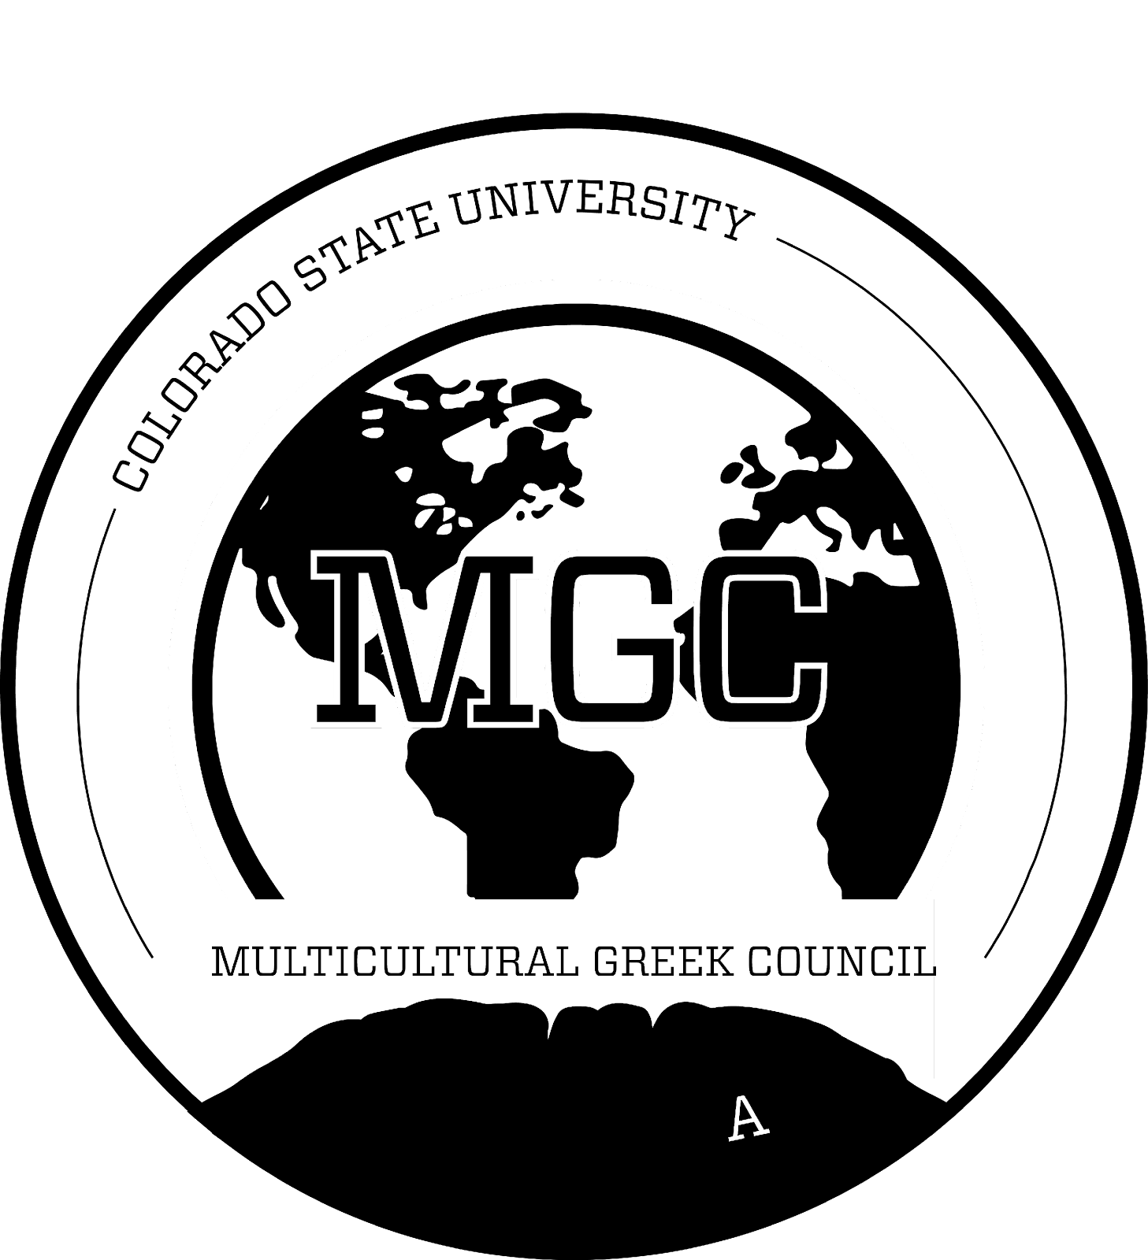
Multicultural Greek Council
Colorado State University

April 3, 2023

- Call to Order
  - Time: 4:34 p.m.
  - Second: [Honey]
- Roll Call
- Approval of Minutes
- First Open Period
  - Programming board- Plan homecoming, national ritual week, F/S fest, senior recognition National ritual week new member programing.
  - Applications are open on the FSL website- Close April 14th.
  - Looking for more representation from MGC
- Executive Officer Reports
  - President (mgccsupresident@gmail.com)
    - Goals Check in
Mid-Semester Check in: Looking over goals that were set at the beginning of the semester.
Goal 1: Communication
What we have done: We have been able to create a new MGC group chat, more engagement within delegates, and more activity within the instagram.
What we could improve on: More time to relay information, more interactions, not talking down on eachother or placing blame on eachother. We are all human, supporting the community and each other regardless of what they have done and haven't done for you.
Goal 2: Accountability-
What we have done: We have been able to fill the whole exec board.
What we could improve on: Not filling out important info or wanting to engage within the community. Have more check-ins where we can hold each other accountable. How has the FSL office been held accountable or How has FSL given back to us or how has MGC given toFSL?? Having an open mind when it comes to engaging within IFC or Panhellenic.
Goal 3: Will be discussed at the next agenda.

  - Executive Vice President (mgccsuvicepresident@gmail.com)
    - No Report

  - Vice President of Judicial Affairs (mgccsu.judicialaffairs@gmail.com)
    - No Report

  - Vice President of Risk Reduction (mgccsu.riskmanagement@gmail.com)
    - Get Yourself Tested Campaign
Exams will only be 20$- Chance to enter a raffle

  - Vice President of Scholarship (mgcscholarshipcsu@gmail.com)
    - No Report

  - Vice President of Council Development (mgccsudevelopment@gmail.com)
    - Fall NM Dates
      - September 2nd, September 16th
It will be a half day event, lunch will provided
Allow us to create more meaningful connections within the community
New Member Mingle will be September 2nd

  - Vice President of Council Events (mgccsuevents@gmail.com)
    - Update on mgc stompz/future plans
    - Thoughts/ concerns for Fall summit and Rooted in culture dates
      - October 13th (Fri) for rooted in culture
      - September 16th, September 23rd for Summit
    - Please do post event forms

We are hoping to plan an end of year celebration in place of Stompz this semester.
End of year celebration - April 28th
Fall Rooted in Culture- October 13th
Summit - September 23rd

  - Vice President of Public Relations (mgccsupublicrelations@gmail.com)
    - No Report

- Chapter Reports
  - Alpha Phi Gamma National Sorority, Inc. (missing)
    - No Report

  - Beta Gamma Nu Fraternity, Inc. (missing)
    - No Report

  - Delta Xi Nu Multicultural Sorority, Inc.
    - Hi! I hope everyone is doing well! Be on the lookout for some exciting events :)
  - Gamma Zeta Alpha Fraternity, Inc.
    - Wishing everyone a good week

  - Kappa Delta Chi Sorority, Inc.
    - Stay safe everyone!

  - Lambda Sigma Upsilon Latino Fraternity, Inc.
    - We are having our Chipotle Fundraiser tomorrow! Hope to see you there
    - 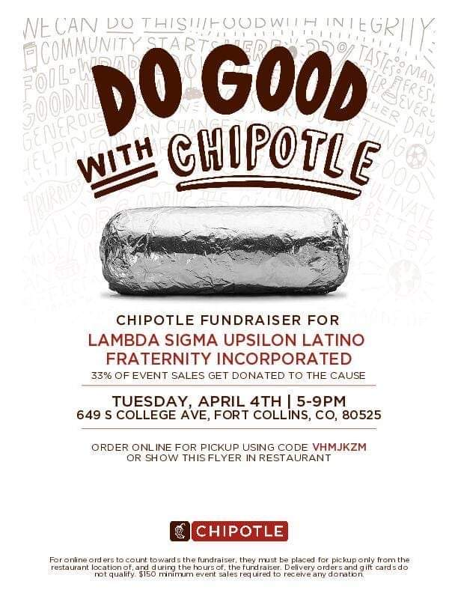
    - New member presentation this Thursday at 8:12PM located at UC Bear @UNC. For more information visit unco_upsilons through Instagram or contact myself or Felix Garcia. Hope to see you there!

  - Lambda Theta Nu Sorority, Inc.
    - Arroz con Leche Fundraiser! Proceeds going to our Latina Youth Leadership Conference <3.
- Pickup Friday 3:30pm - 5:00pm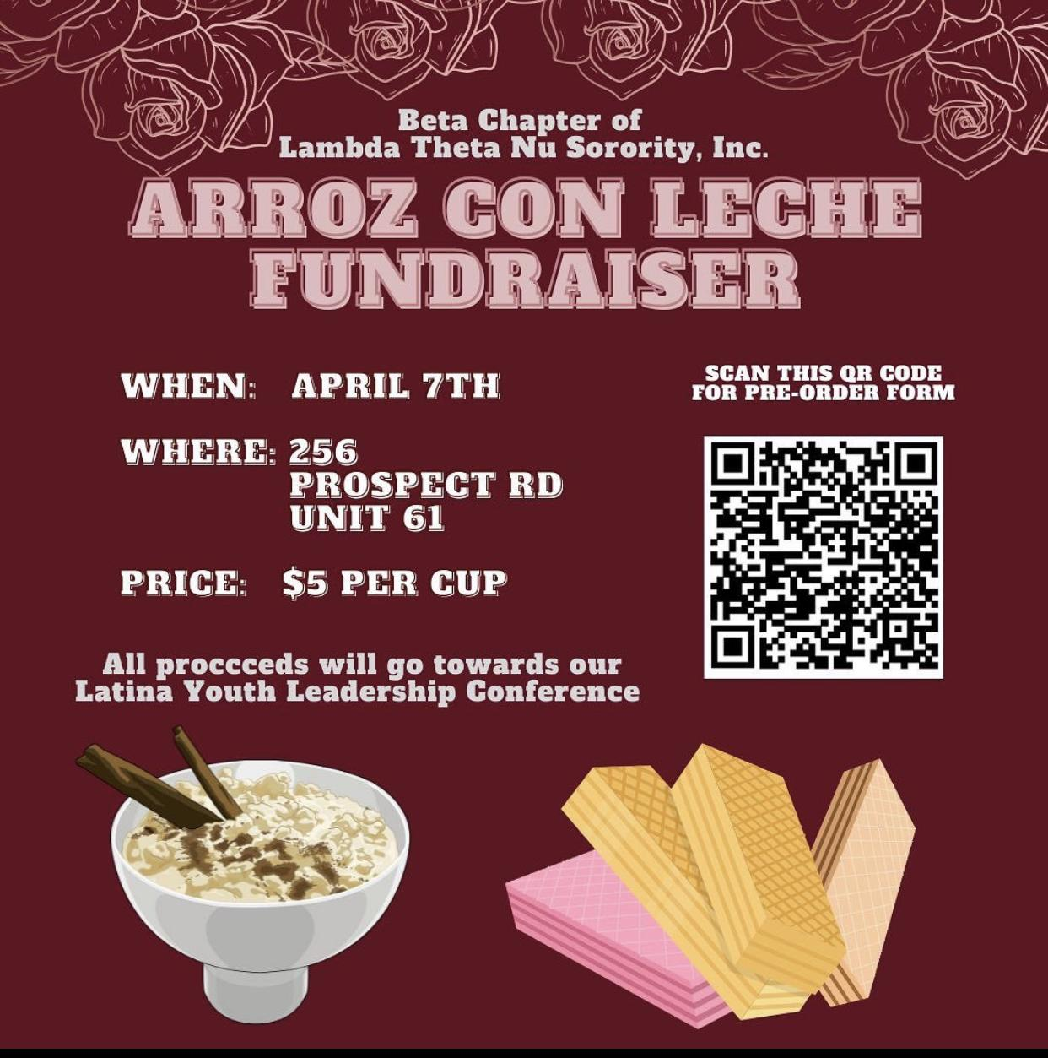

  - Nu Alpha Kappa Fraternity, Inc.
    - This week we are celebrating founders week! Hope you all keep checking out our instagram page for some creative things
    - Next Monday April 10th, is our Chapters founders day and we are having Nacos-Tacos hope to see y'all there!

  - Pi Lambda Chi Latina Sorority, Inc.
    - Our Black and White Ball is next week on Friday
      - Keep an eye out for flash sales
- Thursday April 13th: Self Defense Workshop

  - Sigma Lambda Beta International Fraternity, Inc.
    - Weekend in Vietnam April 4th University of Colorado Boulder
    - Community Service Downtown Feed the Streets April 6th University of Denver
    - Darren “Torre” Parks Youth Leadership Conference April 7th Auraria Campus MSU Denver
    - Highway Clean Up/ Brotherhood Event April 8th
Colorado State University

- Keep an eye out for our BetaDogs Fundraiser!
https://docs.google.com/forms/d/e/1FAIpQLScV_kgFVrw2PohJ1biRmyk356XRl9g2huelfa3HIAv7_RcjNw/viewform?usp=pp_url

  - Sigma Lambda Gamma National Sorority, Inc.
    - Thank you to everyone who made a purchase from Majestic Charms
    - We have Gamma Week this week
    - We’re looking forward to celebrate Founders this Sunday
    - We are having a Canes Findraiser on April 19th, 2023

  - Sigma Omega Nu Latina Interest Sorority, Inc.
    - Hope everyone has a fun and exciting.

- Advisor Reports Yulissa Chavez (Yulissa.Chavez@colostate.edu)
  - Asian Pacific Islander Desi American (APIDA) & Southwest Asian North African (SWANA) Heritage Month
    - Today: Keynote speaker Masih Alinejad at 5:30 LSC ballrooms
    - Tomorrow: City of Foco SWANA Heritage Month Proclamation
    - Tomorrow: Movement Series: Tinkling 6 pm at LSC Theatre
    - Wednesday: Chi Some Poetry 5 pm in APACC
    - Thursday: Weston Estate Concert 6pm at LSC Theatre
    - And more! @CSU.APACC
  - Sexual Assault Awareness Month (SAAM)
    - Wednesday: Understanding and Building Boundaries Group 3:30 -4:45 pm
    - Wednesday: SAAM Kick Off: The Hunting Ground 6-8:30 in Eddy 212
    - And more @CSU_WGAC
  - WGAC job opportunity
    - Summer Peer Educator with Red Whistle Brigade
- Old Business
- New Business
- Second Open Period
- Adjournment
  - Time: 5:30 p.m.
  - Second: [Chapter That Seconded]

