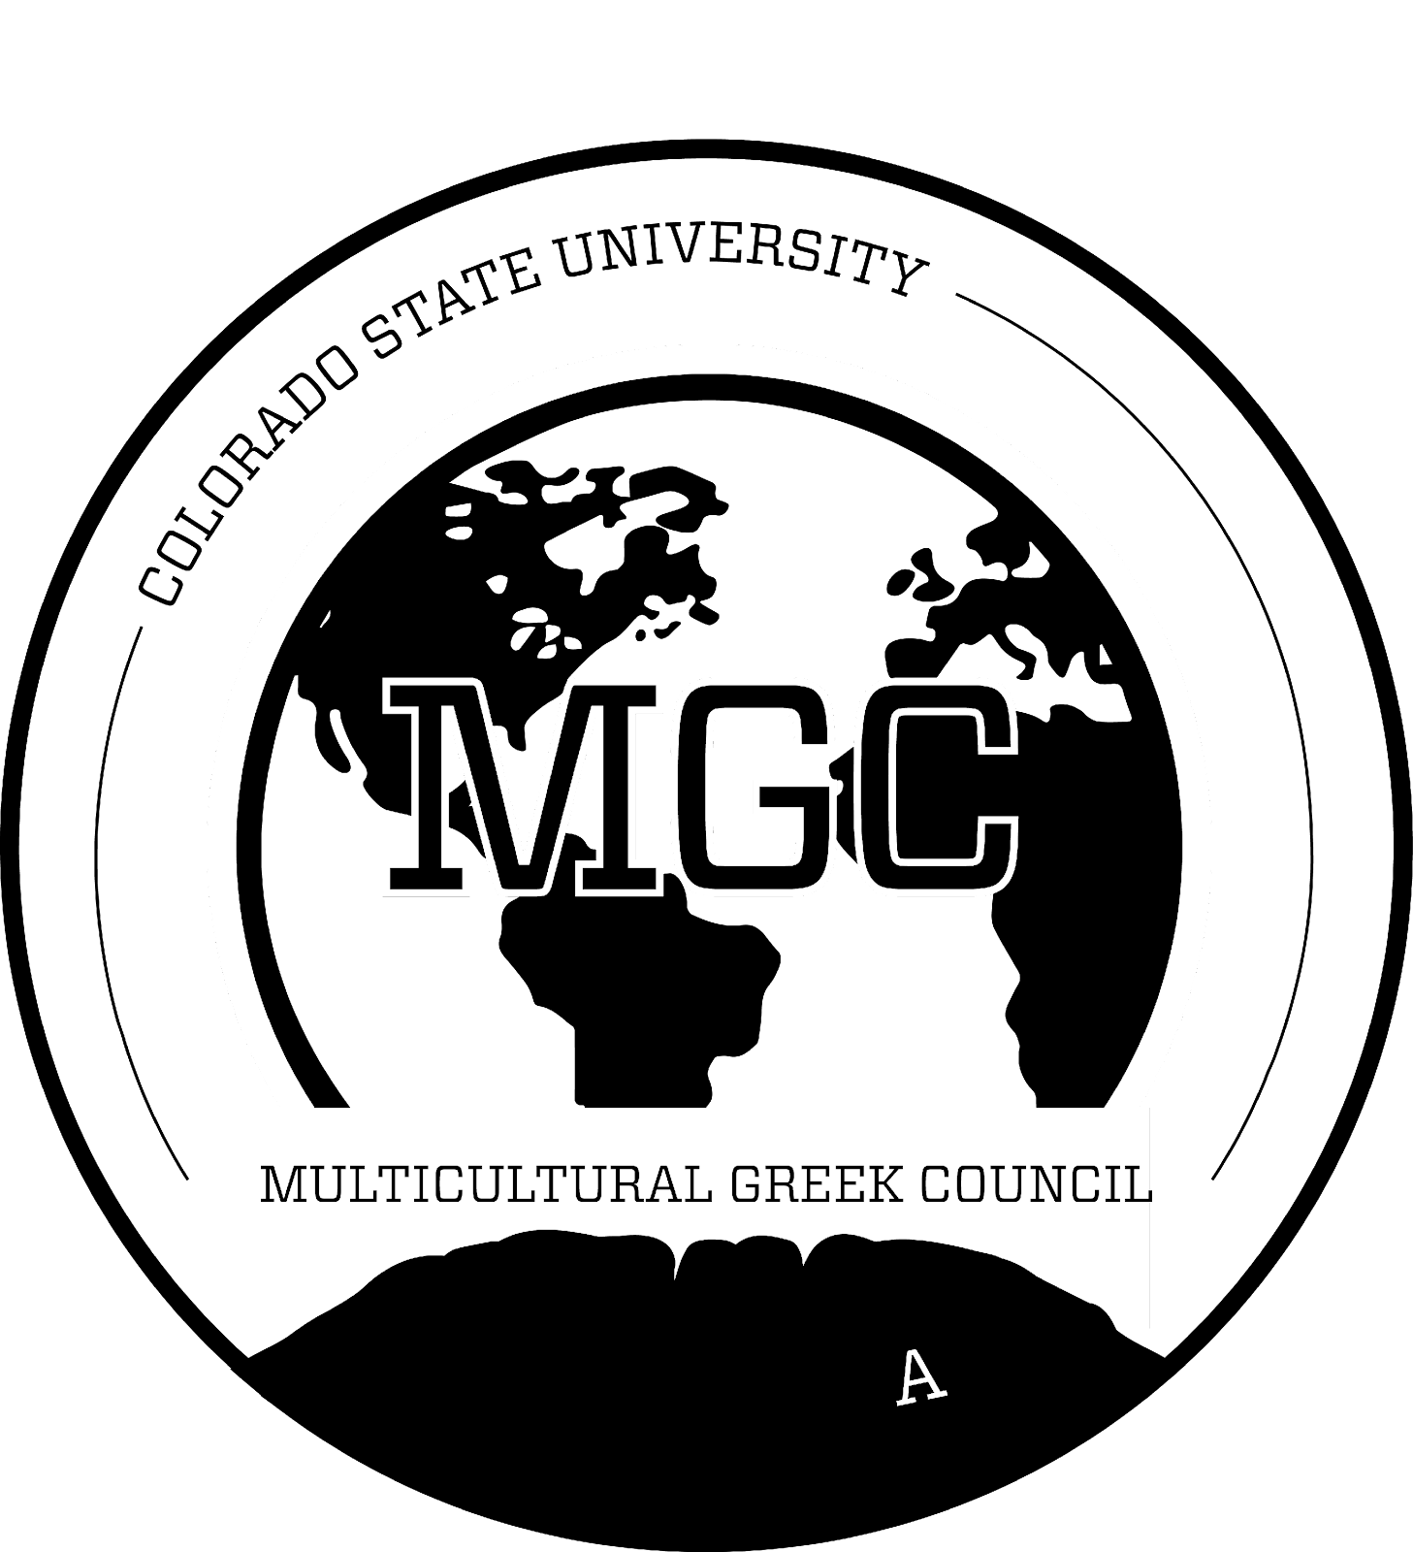
Multicultural Greek Council
Colorado State University

April 10th, 2023

- Call to Order
  - Time: 4:30 p.m.
  - Second:
- Roll Call
- Approval of Minutes
- First Open Period
- Executive Officer Reports
  - President (mgccsupresident@gmail.com)
    - Review last goal
Transparency- What we have done
- Office hours and filled out info about awards and what has been done
What needs improvement-
- More communication about delegate times and sooner emails
- Please reach out to MGC exec with questions or concerns ( we only know as much as were told)
Final thoughts- Work on improving IPV committee
  - Executive Vice President (mgccsuvicepresident@gmail.com)
    - No Report

  - Vice President of Judicial Affairs (mgccsu.judicialaffairs@gmail.com)
    - No Report

  - Vice President of Risk Reduction (mgccsu.riskmanagement@gmail.com)
    - IPV Committee Meeting on April 26th at Eddy 100 from 5-6pm

  - Vice President of Scholarship (mgcscholarshipcsu@gmail.com)
    - For these chapters, please reach out to your academic chairs to find a time to meet with me regarding chapter GPA & other academic support/resources
      - Kappa Delta Chi Sorority, Inc.
      - Sigma Omega Nu Latina Interest Sorority, Inc.
      - Beta Gamma Nu Fraternity, Inc.
      - Sigma Lambda Gamma National Sorority, Inc.
      - Gamma Zeta Alpha Fraternity, Inc.
    - MGC study night April 25th, 6-9 PM in Eddy 7th
Emails have been sent for the following orgs about meeting with scholarship
  - Vice President of Council Development (mgccsudevelopment@gmail.com)
    - Reminder: Fall NM Mingle will be on September 9th (not the 2nd)
      - Keep morning times available
This day is no longer the correct date - Date TBD
  - Vice President of Council Events (mgccsuevents@gmail.com)
    - Need to pick a new date for summit
      - September 17th (sunday after CSU vs CU Boulder game)
      - Sunday October 1st
      - October 8th (sunday before homecoming week)
    - Rooted in Culture pending for Friday October 20th
    - April 28th, 6-8 MGC end of semester celebration. Keep the day open!!
Summit will now be October 1st

  - Vice President of Public Relations (mgccsupublicrelations@gmail.com)
    - FSL Insert Booklet
      - The FSL office is planning this upcoming year's booklet. It's the flier for the FSL Office where they include all of the council's basic information!
      - Ad
        - I sent out an email to your presidents earlier this afternoon with information on promoting your organization! Reach out if they weren't able to receive it!
    - Shared FSL Picture Drive
      - I encourage you all to upload any pictures from your chapters! This can be member pictures, community service, philanthropy events, and etc.
      - Use them to promote and highlight your chapter!
      - Folder: click here
- Chapter Reports
  - Alpha Phi Gamma National Sorority, Inc.
    - We have a Chipotle Fundraiser tomorrow from 4-8 so join us! <3

  - Beta Gamma Nu Fraternity, Inc. (Missing)
    - No Report

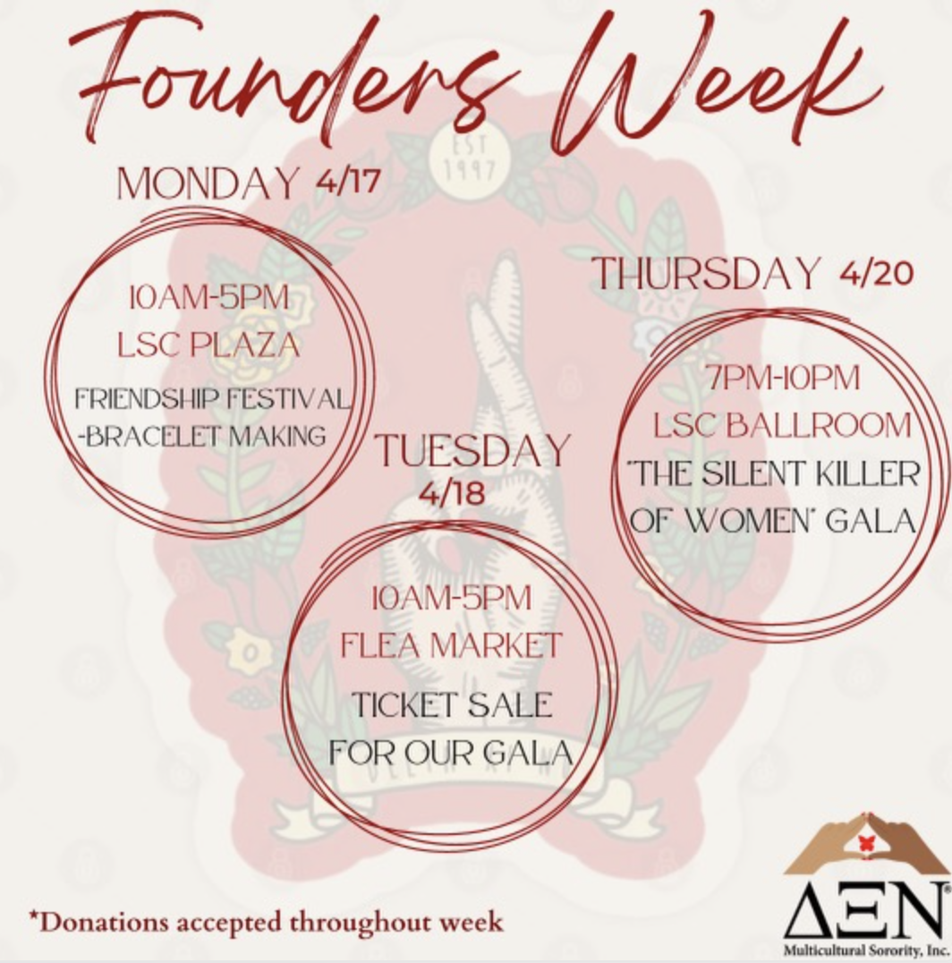
  - Delta Xi Nu Multicultural Sorority, Inc.
    - Our founder’s week is next week April 17th
    - Here are events to look forward too :) Hope to see y’all there

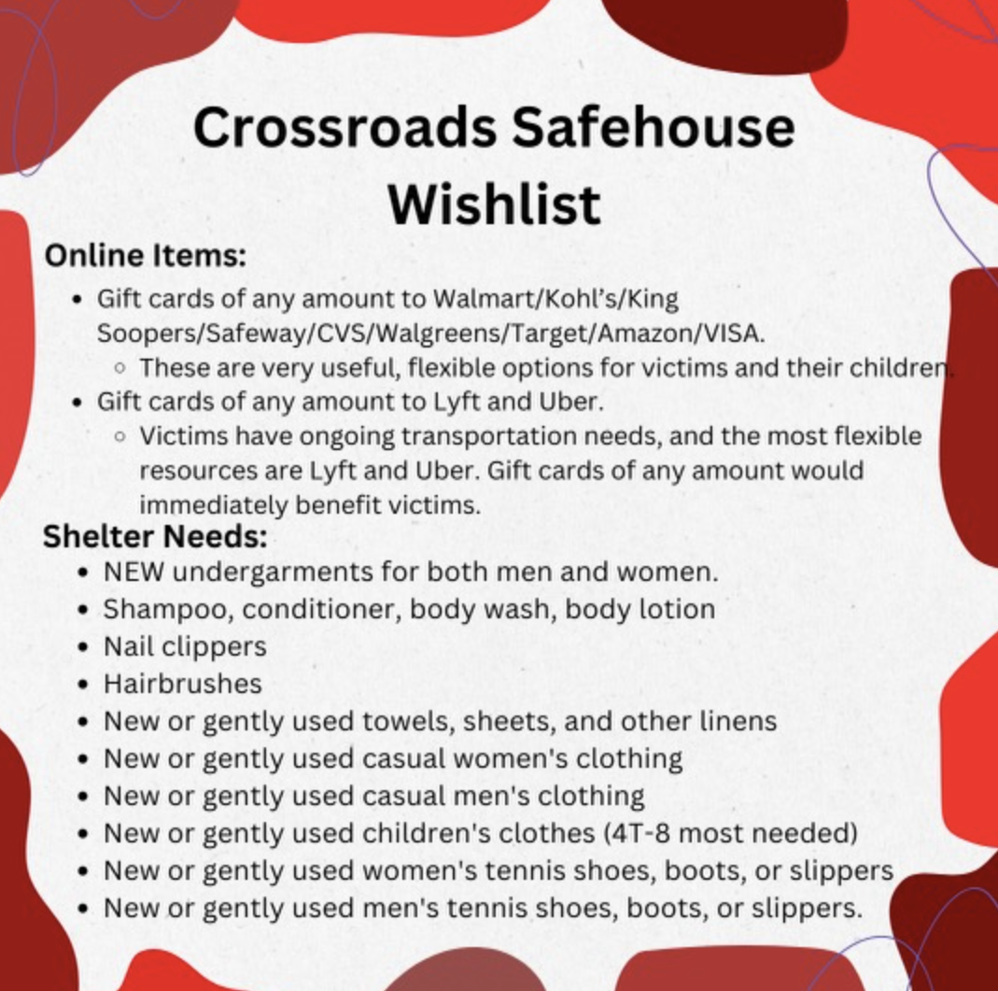
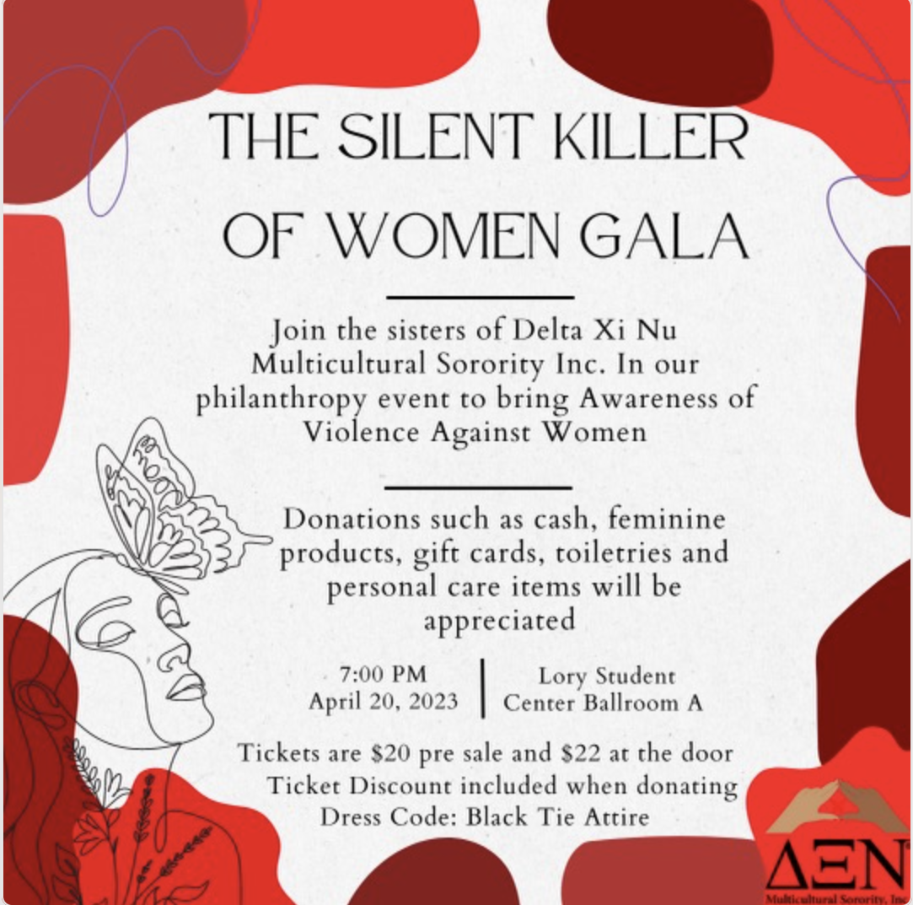

  - Gamma Zeta Alpha Fraternity, Inc.
    - Be on a look out for future fundraisers:
      - Gammalotes: April 20th
      - Mangonadas: May 5th
    - Reminder: our academic chair has reached out to Vice President of Scholarship, waiting for response

  - Kappa Delta Chi Sorority, Inc.
    - Stay safe everyone!

  - Lambda Sigma Upsilon Latino Fraternity, Inc.
    - Thank you everyone who joined us for our Chipotle Fundraiser!
    - National Upsilon Day of Service was a success!
    - Be on a look out for more events
    - 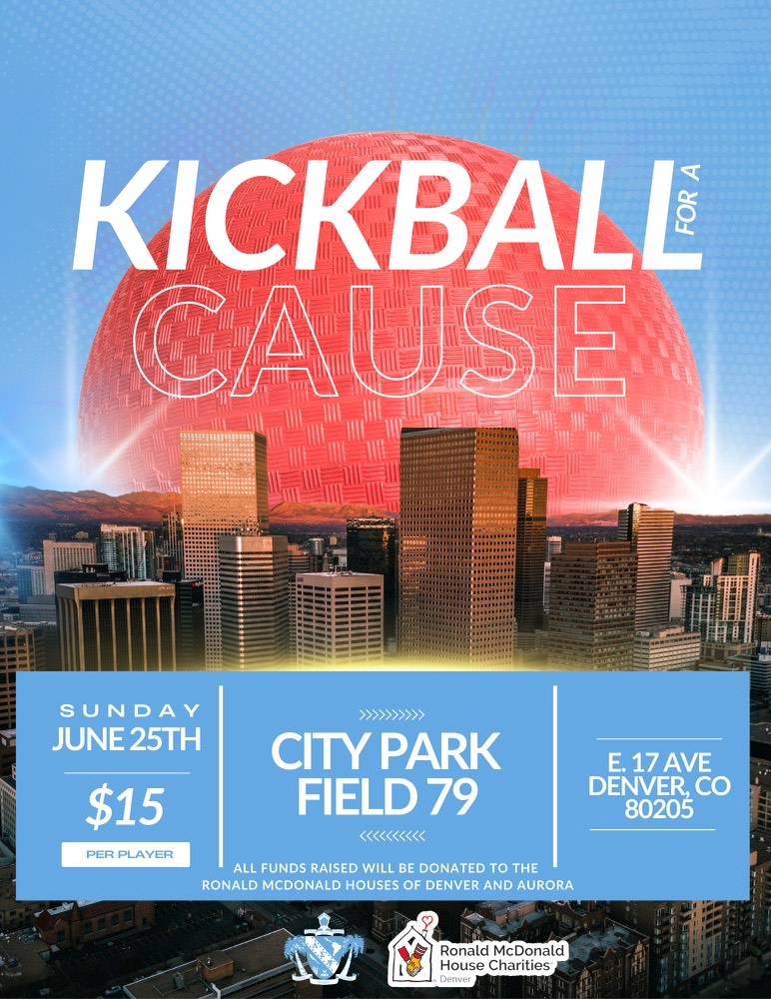
    - Keep you all posted for New Presentation at UNC.

  - Lambda Theta Nu Sorority, Inc.
    - No Report

  - Nu Alpha Kappa Fraternity, Inc.
    - Thank you to everyone and every org who wished us a happy founders day today along with supporting our fundraiser Nakos-tacos, we really appreciate it.

  - Pi Lambda Chi Latina Sorority, Inc.
    - Founders week
    - 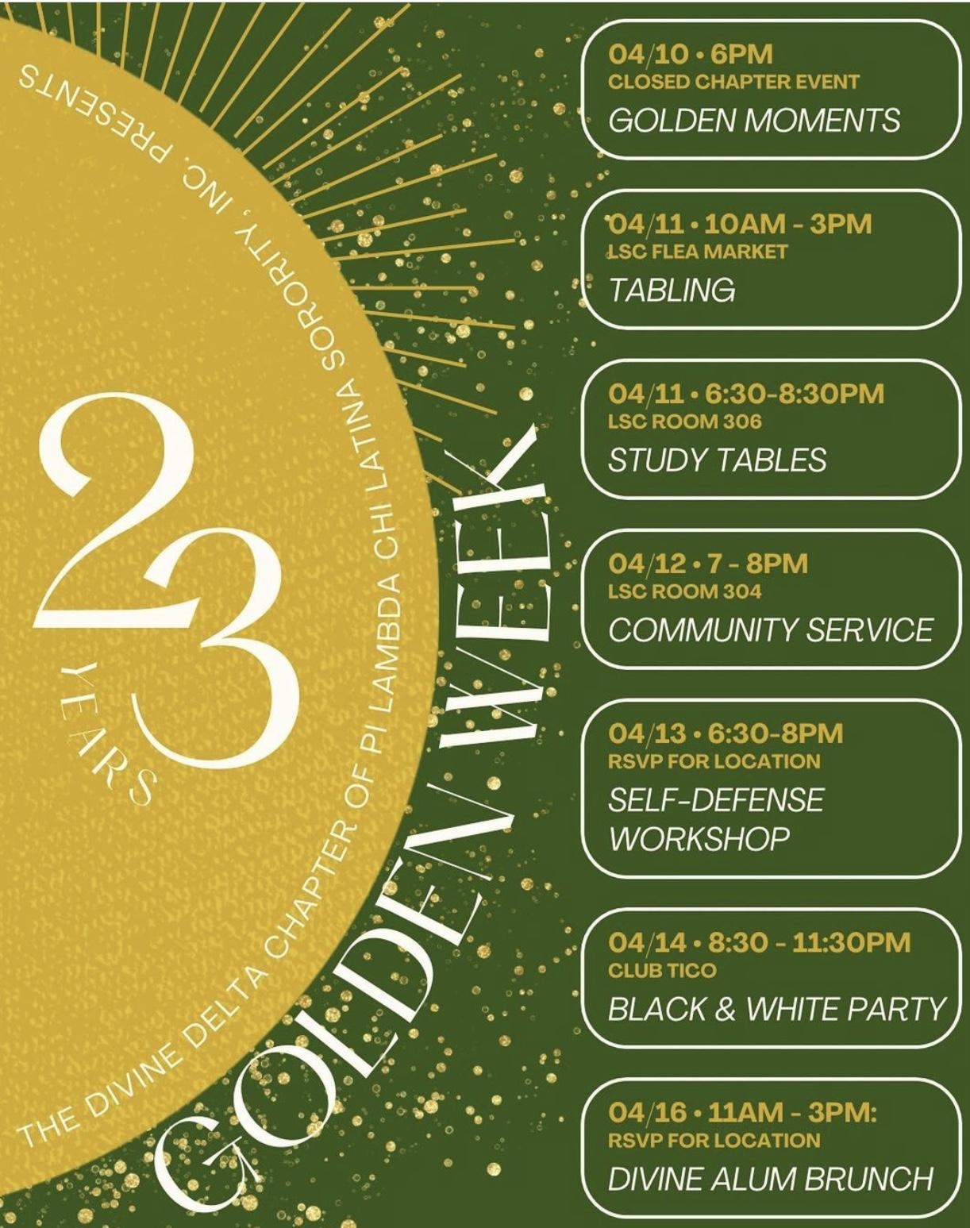

  - Sigma Lambda Beta International Fraternity, Inc.
    - Keep an eye out for some fundraisers coming up.

  - Sigma Lambda Gamma National Sorority, Inc.
    - Raising Cane's fundraiser on Wednesday, April 19th 5-9
    - Our chapter sister #106 Carla "Inti" Rey Diaz passed away this weekend
      - https://gofund.me/5b9ff567

  - Sigma Omega Nu Latina Interest Sorority, Inc.
    - Hope everyone had a nice weekend!

- Advisor Reports Yulissa Chavez (Yulissa.Chavez@colostate.edu)
  - Apply to Campus Step Up social justice Retreat
    - Hosted in Estes Park, this all expenses paid overnight retreat is May 13th-May 14th for CSU student leaders!
  - Information Technology in Business summer program for high school students
    - June 19th -23rd 9 am - 3pm
    - No cost, lunch included
  - Programming board applications:https://fsl.colostate.edu/programming-board-application/
  - F/S Programming Board Senior Recognition tentative for May 5th 5-6:30 pm
  - Move in intent form
- Old Business
- New Business
- Second Open Period
- Adjournment
  - Time: 5:20 p.m.
  - Second: [NAK]

