Multicultural Greek Council
Colorado State University

February 13th, 2023

- Call to Order
  - Time: 4:34 p.m.
  - Second: [Lambda]
- Roll Call
  - Alphi Phi Gamma
  - Beta Gamma Nu
  - Delta Xi Nu
  - Gamma Zeta Alpha
  - Kappa Delta Chi
  - Lambda Sigma Upsilon
  - Lambda Theta Nu
  - Nu Alpha Kappa
  - Phi Lambda Chi
  - Sigma Lambda Beta
  - Sigma Lambda Gamma
  - Sigma Omega Nu
- Approval of Minutes
- First Open Period
  - Alejandra with UDU- Service opportunity with ramride. 8 hours of volunteer hours.
- Executive Officer Reports
  - President (mgccsupresident@gmail.com)
    - MGC Fundraisers - steps moving forward?
It was brought to our attention that some MGC organizations have been using other organizations' fundraising ideas such as food sales. For example, the PLC’s always sell sopapillas. What would it mean if another organization sold this item? How can we ensure everyone feels respected without limiting who can put on certain fundraisers?

Comments shared in the discussion:
- It is common courtesy to respect others' events and fundraisers' ideas.
- We should ask the chapter if it's okay if you use their fundraiser idea.
- How do we define whose event is whose?
- We should focus on signature everts, while keeping food sales open.
- No one organization can claim food items for sales, but we can make sure that we are being courteous of other organizations.
Outcome: Each delegate will bring a list of events/fundraisers that are common to their organization, so that all chapters can keep these events in mind when deciding to do a certain fundraiser or event.

Important to know:
- You cannot have signature events on other organizations' national or chapter founding day, this is in our bylaws.
- We often change and update our bylaws, please read and look over.

  - Executive Vice President (mgccsuvicepresident@gmail.com)
    - No Report

  - Vice President of Judicial Affairs (mgccsu.judicialaffairs@gmail.com)
    - No Report

  - Vice President of Risk Reduction (mgccsu.riskmanagement@gmail.com)
    - No Report

  - Vice President of Scholarship (mgcscholarshipcsu@gmail.com)
    - Bylaws & Tier System
    - Sending out academic action plan revisions (if applicable)
Per MGC bylaws the minimum GPA requirement is a 2.5 if you are below you will enter the tier system. Tier One- Warning Status , Tier Two- Academic Probation Status, Tier Three- Inactive Status. https://fsl.colostate.edu/current-students/elevation-resourses/ Action plan needs to be sent to MGC scholarship with revisions.

  - Vice President of Council Development (mgccsudevelopment@gmail.com)
    - New Member Mingle this Wednesday 02/15
      - Eddy 100
      - 5:00pm - 6:30pm (70% attendance required)
      - New Member Educators are welcome to join with their neos :)

  - Vice President of Council Events (mgccsuevents@gmail.com)
    - No Report

  - Vice President of Public Relations (mgccsupublicrelations@gmail.com)
    - Wear Em Wednesday @ New Member Mingle, if you'd like! We will be taking Pictures!

- Chapter Reports
  - Alpha Phi Gamma National Sorority, Inc.
    - No Report

  - Beta Gamma Nu Fraternity, Inc.
    - No Report

  - Delta Xi Nu Multicultural Sorority, Inc.

    - Keep up the great work :) We loved supporting everyone’s fundraisers
    - We have some fun, amazing, and wonderful events coming soon.. stay tuned
  - Gamma Zeta Alpha Fraternity, Inc.
    - Wishing everyone an amazing start to their week!
    - The brothers of Gamma Zeta Alpha Fraternity, Inc. welcome everyone to join us for Valentine’s Day! If you would like to purchase beautiful roses for someone special, we will be selling roses at el Centro and at the LSC flea market from 10am-4pm. Below is the flier with more information. (Pre-sale options are still open for those that would like to place their orders ahead of time or are considering delivery!) We would greatly appreciate everyone’s support!
    - 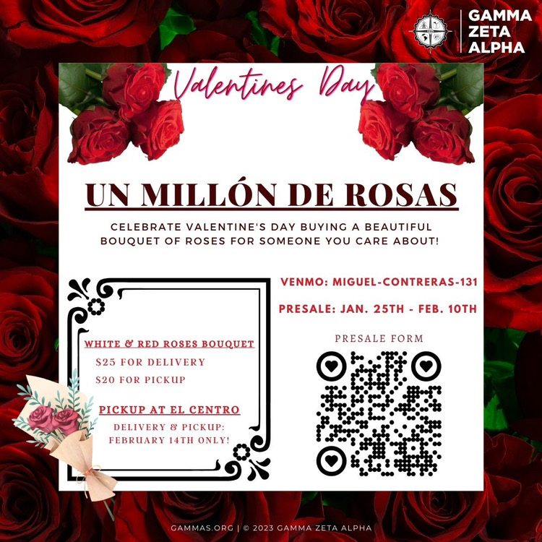

  - Kappa Delta Chi Sorority, Inc.
    - Culture Night this Thursday!
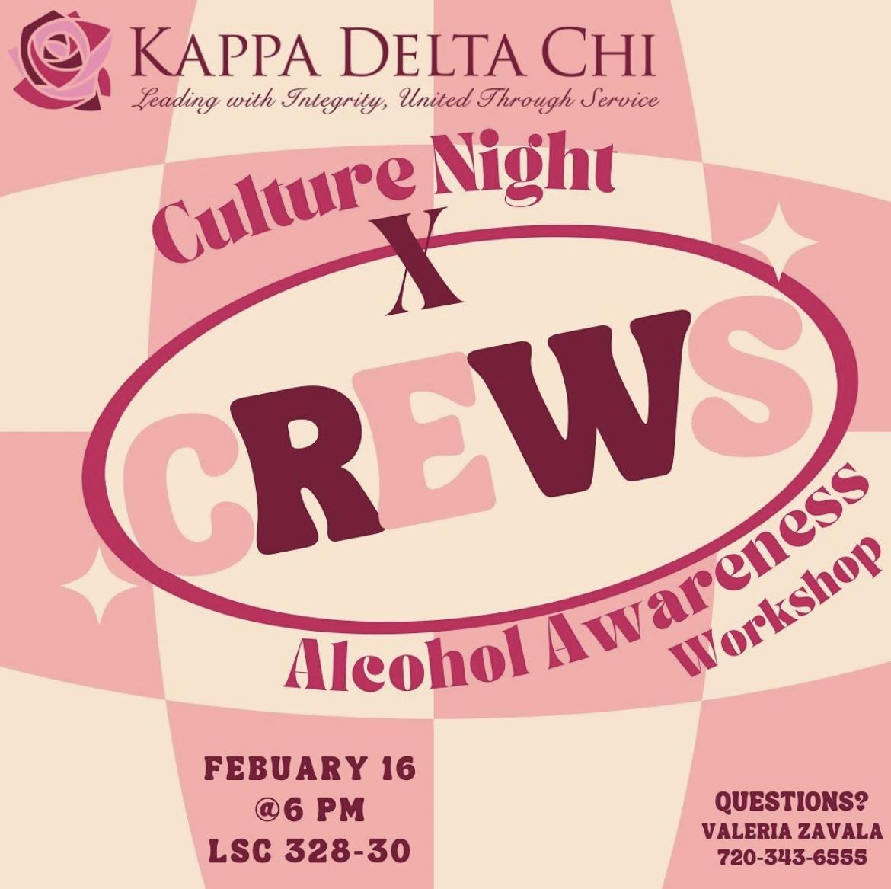
    - Keep an eye out for our upcoming fundraiser!!

  - Lambda Sigma Upsilon Latino Fraternity, Inc.
    - It’s week 6. Keep up with the good work everyone!

  - Lambda Theta Nu Sorority, Inc.
    - Panda fundraiser February 28th 11am-7pm !

  - Nu Alpha Kappa Fraternity, Inc.
    - We would like to thank everyone who came to support our fundraiser as well as for supporting and coming out to our SAVA workshop. We really appreciate everyone who came out and shared our flier.

  - Pi Lambda Chi Latina Sorority, Inc.
    - Thanks for sharing our flier for past informationals
    - Email

  - Sigma Lambda Beta International Fraternity, Inc.
    - Keep an eye out for some upcoming events.

  - Sigma Lambda Gamma National Sorority, Inc.
    - Gamma Week will be next week from 2/20-2/24! We will be posting more information soon on Instagram.
    - Reminder for frats to reach out to associate with us again

  - Sigma Omega Nu Latina Interest Sorority, Inc.
    - Hope everyone had a fun and safe weekend! Sigma Omega Nu sisters would like to thank everyone who came to support our fundraiser as well as reposting/sharing our flier.

- Advisor Reports Yulissa Chavez (Yulissa.Chavez@colostate.edu)
  - F/S Fest Opt-in form is due Friday, February 24th
Please encourage your chapter to attend and participate. All MGC organizations pay for these events to be put on so please get the most out of it.
MGC Stompz is scheduled for April 3rd.
Lip sync battle April 5th
Picnic/spots April 7th
Trivia night April 11th
Soft ball game April 12th
- Old Business
- New Business
- Second Open Period
  - We are currently hiring Admissions Ambassadors for the fall semester, and we would really appreciate your help to market the position within your chapters. The application closes this February 25th at midnight. I am going to hand out a flier to each of you with a QR code that can be scanned by anyone who is interested in the position. If you could share this flier with your chapters by taking a picture and sending it to your members, that would be amazing. Do y’all have any questions?
- Adjournment
  - Time: 5:23 p.m.
  - Second: [APhiG]

